Synopsis

Project Title- Heart Disease Prediction System

Problem Id: 18

Student Name- Inakshi
University Roll number- 2028431
Section- G

Student Name- Vishwajeet singh
University Roll number- 2028515
Section- G

- Problem Description:
Heart disease is a leading cause of mortality globally. Early detection is critical, but manual clinical analysis of patient records (like blood pressure, age, cholesterol, and EKG data) is time-consuming and prone to human error. This project aims to develop an automated Heart Disease Prediction System using machine learning. By analyzing historical clinical data, the system identifies non-linear patterns and correlations that may be invisible to the human eye. In a real-life medical context, such a tool can serve as a Decision Support System (DSS), allowing doctors to quickly flag high-risk patients for prioritized care, thereby reducing diagnostic delays and improving life-saving intervention rates.

- Steps of Implementation:
- Environment Setup & Data Loading: Import essential libraries (pandas, numpy, matplotlib, sklearn) and load the heart disease dataset.
- Data Preprocessing (Data Cleaning): Handle missing values by using imputation techniques (e.g., filling with the mean) and perform feature encoding to convert categorical clinical data into numerical formats.
- Exploratory Data Analysis (EDA): Use visualization tools to understand correlations between variables—such as the relationship between cholesterol levels, age, and the target heart disease diagnosis.
- Feature Scaling & Dataset Splitting: Apply feature scaling (e.g., StandardScaler) to normalize data ranges, which is critical for distance-based models like KNN.
- Model Training (Logistic Regression & KNN): Initialize and train the Logistic Regression model for linear classification and the K-Nearest Neighbors (KNN) model for non-linear pattern recognition.
- Performance Evaluation & Comparison: Predict outcomes on the testing set and calculate key metrics: Accuracy, Precision, Recall, and F1-Score. Generate a Confusion Matrix to visualize the classification results.

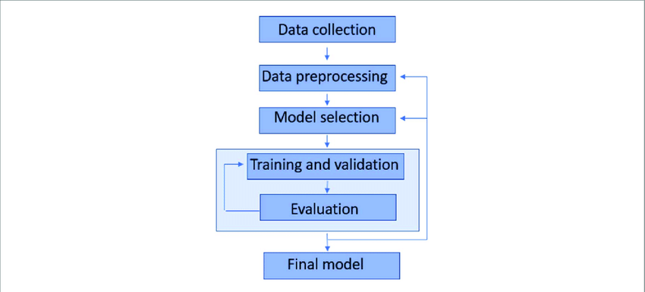

- Expected Modules/ Libraries to be used:
- Pandas: Used for data manipulation, cleaning, and handling missing values in the clinical dataset.
- NumPy: Used for high-performance mathematical calculations and efficient array operations.
- Scikit-learn (Sklearn): The core library for machine learning; used for data splitting, scaling, training the models, and calculating evaluation metrics.
- Matplotlib/Seaborn: Used for data visualization to create heatmaps and confusion matrices, helping to interpret model performance.

- Expected Evaluation metrics and Plots to be used:
- Accuracy: Gives the overall percentage of correct predictions.
- Precision and Recall: Crucial for medical datasets; Recall is prioritized because it measures the model's ability to identify all actual heart disease cases (minimizing false negatives).
- F1-Score: Provides a balanced mean of Precision and Recall, useful if the dataset has class imbalance.
- Confusion Matrix (Plot): A visual grid showing actual vs. predicted classes, which helps pinpoint where the model is making errors.

- Required topics from the subject:
- Files (File I/O): Essential for loading the clinical dataset (usually in .csv format) into the environment so the program can process the raw data.
- Strings: Used to process categorical data within the dataset (e.g., converting text-based labels like "Male"/"Female" or "Chest Pain Type" into numerical format for the model).
- Functions/Modules: Used to modularize the code, allowing the separation of data cleaning, model training, and prediction logic into reusable blocks for cleaner, more maintainable code
- Platform Required:
Spyder: for its robust, scientific-grade IDE environment, offering powerful variable inspection, integrated debugging, and a professional layout ideal for developing and refining modular machine learning pipelines.

- Books and Link Sources:
- Scikit-learn Official Documentation: (scikit-learn.org)
- Heart Disease Dataset page: (www.kaggle.com)
- Matplotlib Documentation: (matplotlib.org)
- Pandas Documentation: (pandas.pydata.org)

